Results for Pima Indian Dataset:

Parameters:

**Monte Carlo Size = 50 Trials**

Sample Sizes: 10-530, Step Size=Not constant

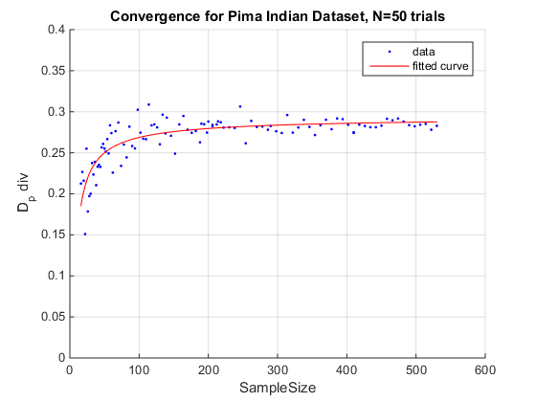

dpdivFitI(x) = a*x^b+c

Coefficients (with 95% confidence bounds):

a = -0.9571(-1.823, -0.09145)

b = -0.7831(-1.099, -0.467)

c = 0.2947(0.2823, 0.307)

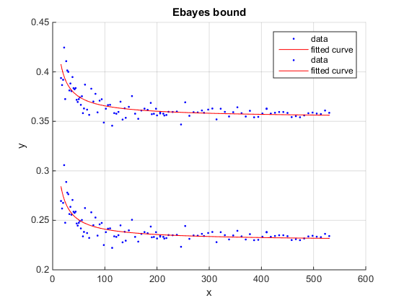

|  |  |
| --- | --- |
| Ebayes |  |
| Lower Bound | 0.2285 (0.2226, 0.2345) |
| Upper bound | 0.3527 (0.3466, 0.3589) |

**Dp div value vs sample size**

Asymptotic method much better at dealing with variability at small sample size values (N=100)

Parameters:

**Monte Carlo Size = 200 Trials**

Sample Sizes: 10-530, Step Size=Not constant

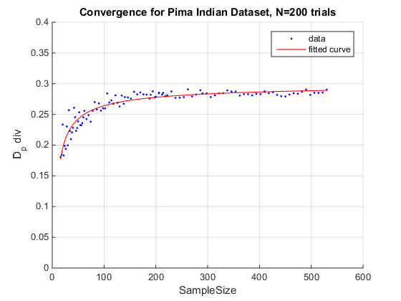

dpdivFitI(x) = a*x^b+c

Coefficients (with 95% confidence bounds):

a = -0.7532 (-1.089, -0.4176)

b = -0.6499 (-0.8146, -0.4852)

c = 0.3019 (0.2913, 0.3124)

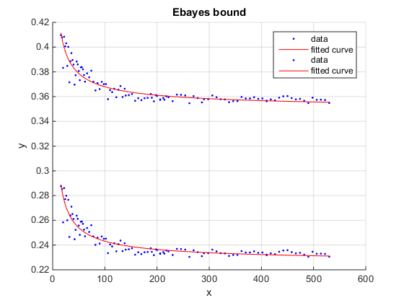

|  |  |
| --- | --- |
| Ebayes |  |
| Lower Bound | 0.2257 (0.2211, 0.2304) |
| Upper bound | 0.3491 (0.3438, 0.3543) |

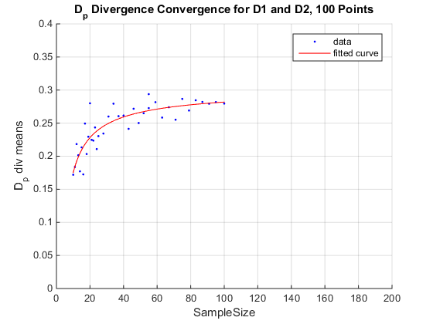

a = -0.7435 (-1.741, 0.2543)

b = -0.7608 (-1.452, -0.06925)

c = 0.3042 (0.2519, 0.3565)

Results for Banknote Dataset:

Parameters:

**Monte Carlo Size = 50 Trials**

Sample Sizes: 10-600, Step Size=Not constant

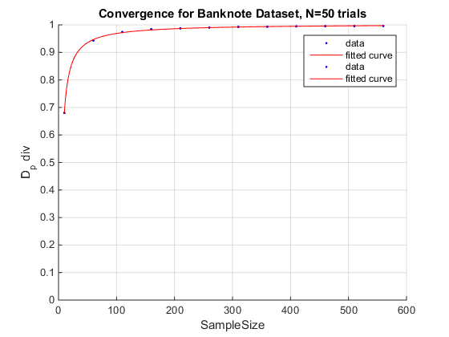

dpdivFitI(x) = a*x^b+c

Coefficients (with 95% confidence bounds):

a = -2.993 (-3.291, -2.695)

b = -0.9655 (-1.011, -0.9203)

c = 1.004 (1.001, 1.006)

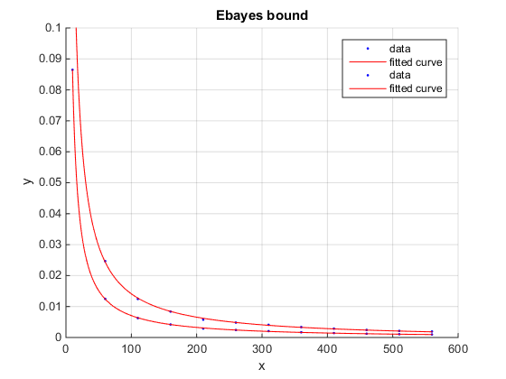

|  |  |
| --- | --- |
| Ebayes |  |
| Lower Bound | -0.0001938 (-0.0003106, -7.698e-05) |
| Upper bound | -0.000681 (-0.0009957, -0.0003664) |

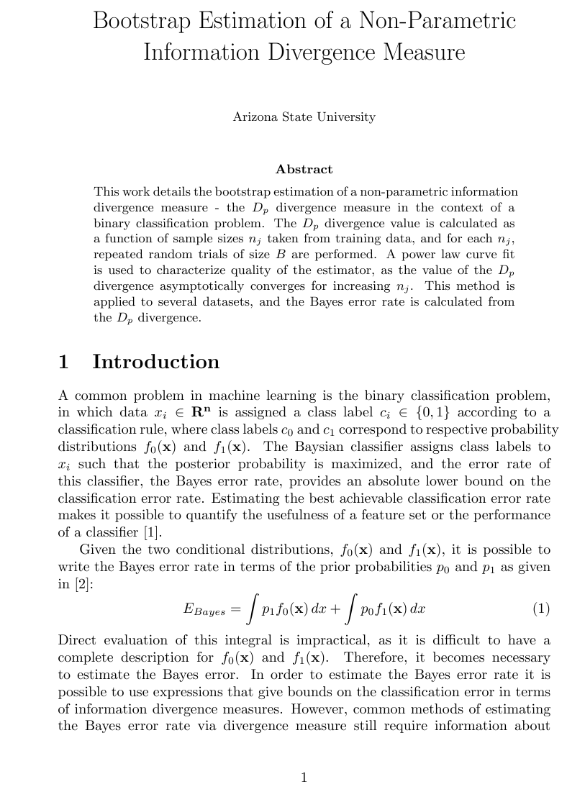

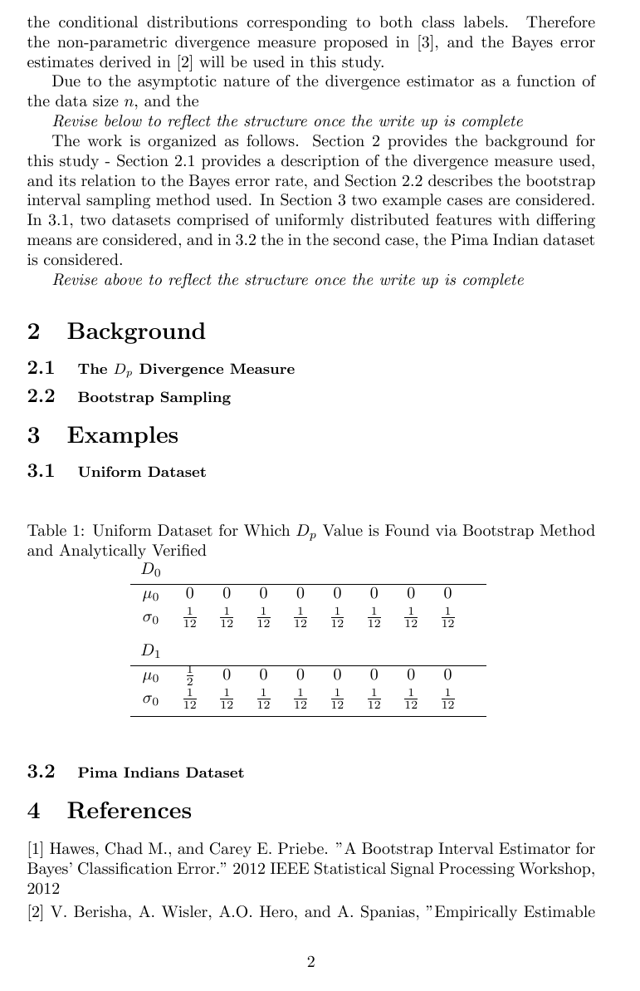

Ignore this page

Parameters:

**(WITH REPLACEMENT)**

Monte Carlo Size = 50

Sample Sizes: 10-1000, Step Size=2

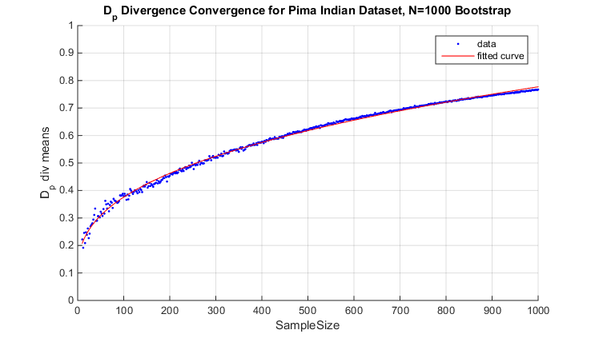

**Resultant Power Law: $L\left(x\right)=0.05n^{0.379}+0.08779$**  (nonsense convergence result)

